8th - 11th of September: This week I started creating my website and learning about different shot types, the website was rather difficult as at first I started my work on Wix which in my opinion is a rather complicated website to use as there are a lot of buttons and I couldn't figure out how to start typing so I switched to Webnode which is a far easier website to use and I am much happier using Webnode over Wix. Learning about shot types was quite easy as I had already learned most of them in level 1.

15th - 18th of September: This week I completed a group project where my group filmed a project about a lost phone. I think that this project went not well at the beginning but once we had input from a teacher it went well as we had various different shot types such as close ups, medium close ups and a Dutch tilt. Once we started editing the project we realised that once we put the clips into Premiere pro, they had no sound and we couldn't figure out why, even after the help of a lecturer. We overcame this by having no sound on the clips, but using free sound effects websites such as Pixabay. This week we also used some toy figures to show different shot types such as an over the shoulder shot, low angle shot and long shot. this week we started writing our own scripts and I wrote a script called "the cursed amulet" about two girls who are in a haunted house looking for a cursed amulet and I wrote half a page of it, and I knew what I wanted to write about next. This week I also started editing my showreel and I put my lost phone film into it. figuring out what to put into my showreel was difficult at first but then became easier once I'd asked for help from a teacher and I was told what I could put in it. This week I also filmed toy human figures in various different shot types and angles such as high angle, low angle and in a master shot, this was quite enjoyable as I found posing and filming the figures quite relaxing.

22nd - 25th of September: this week i started storyboarding the cursed amulet on an app called storyboarder and this app was fun to use as you're able to move the characters around but i found it quite difficult to use as I wanted my character to be looking into a box but i couldn't figure out how to make her lean down a bit more, so in future i think i would consider doing my storyboards on paper rather than storyboarder, or trying to figure out how to position the characters how i want. this week i filmed a montage, match cuts, trucking shots and various other shot types and this was fun as i enjoyed going out and figuring out what to film and i quite liked filming the montage of setting up a tripod as i liked finding ways to make it more interesting. this week i continued editing my showreel and i put in the toy figure footage and edited my montage, editing the montage took quite a while as there were a lot of clips and by the time it got to the end of my college week on Thursday i felt that i wasn't going to be able to finish my showreel as i hadn't even known we had to film multiple of the shot types and camera movements that we were meant to put into our showreel and it was due in on Tuesday the next week so getting everything done felt a bit stressful.

30th September – 2nd of October: This week i started to record the shot types, camera movements and edits that i didn't have such as the tilt, pan, tracking, split screen, extreme close up, establishing shot, eyeline match, whip pan hidden edit, move in, move out, zoom in and zoom out. I am proud of how much we were able to film in two lessons, especially considering it was a group of two people. I found filming all of these shot types quite fun as i much prefer doing practical work over sat down work and doing all of this filming helped me learn the terms that i needed to know. I was also given an extension on my project so this was able to take away some of the stress of not finishing on time, i also found out i only needed a minimum of 5 shot types and 3 movements from the list and i
had 11 shot types, 9 edits and 7 shot types.

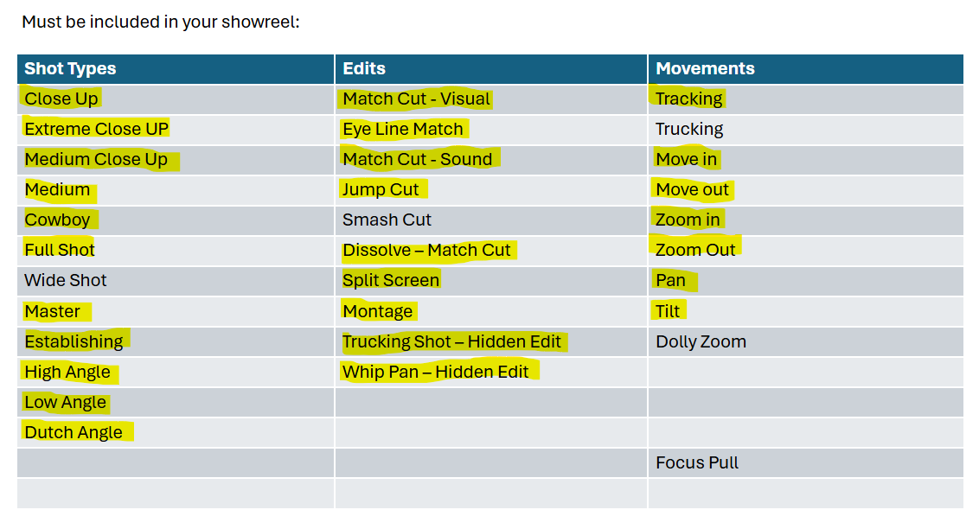

This week i also started storyboarding on storyboarder for my next project about a power shift where two characters are preparing for an interview and one is weak and the other is powerful and then they switch power dynamics. Storyboarding this was a bit difficult as i couldn't quite make the weak character lean down but once I'd figured out how to do that it became easier to storyboard on storyboarder and i was able to make some shot types that i was quite proud of such as a shot where the powerful character is handing the weak character a sheet of paper with their notes on it as i was able to make the powerful character look like it was holding the paper out by using the hand presets. I also completed my website by adding the extra pages for future projects. Another thing i did this week was that i finished my showreel and exported it. I am quite proud of my showreel as it has a lot of the required shot types and I'm only missing 4 of them and i like the way that i made the text for the shot types fade out as it makes it more interesting.

6th – 9th of October: This week i started working on my planning documents for the power shift project, such as a risk assessment, a location recce and a production schedule. This was quite difficult, especially the risk assessment as i wasn't sure what risks to put down as the TV studio which is where we are filming is quite a safe area to be in so i didn't think that would be many risks that we would experience while filming other than tripping hazards such as tripping on cables, table legs, tripod legs etc. This week we also did an editing workshop where we edited three clips together of character animation videos and i didn't get too far into the editing when the internet on multiple of the computers in the room shut off including mine so i lost all of the editing I'd done which was annoying but it wasn't too bad of a loss as it wasn't actual work or something i needed to hand in and the only editing I'd done was trim the first clip and match cut it to the second clip which was an edit i was very proud of and i did end up being able to replicate it once the internet had come back. In future i will start saving projects more frequently to avoid losing work in the future which could possibly be more important.

13th – 16th of October: this week I continued to work on my planning documents including my risk assessment and I managed to complete my risk assessment which turned out to be easier than it was last week with the help of my group. I also finished my location recce which was quite easy as the required things I needed to put into it were quite simple and straightforward. On the last available day to do our pre-production it was quite stressful as we only had one lesson that day and we werent sure if we were going to be able to get it finished in time to start filming but were were able to get it done. The next day we started filming and this went really well as we were able to have some really creative ideas such as making the lights red on the strong character and blue on the weak character and having some interesting shot types such as moving in and doing a dutch tilt at the same time.

20th – 22nd of October: This week I started editing my power shift film and I found it stressful because the first draft was meant to be due tomorrow and I’d only just started editing but other than that I think it went well and I was able to do some interesting edits such as a match cut when the powerful character snatches the paper from the weak one and I am very proud of this and I think it looks smooth. The day after on Tuesday I continued editing and I had a few clips that were a bit too short such as a whip pan from the strong character to the weak character and the clip cut off too soon so I split the clip up and slowed down the video of the weak character to make it longer and I was really proud of this as I wanted to keep the clip but it wouldn’t be good if it didn’t stay on the weak character for longer. On Wednesday I exported my film and started writing my evaluation and this was quite easy but by the end of my day which I had only one lesson that day I wasn’t able to finish my evaluation yet. On thursday i was preparing to submit my assignment and i had to put all of my documents on to my website and at first i ended up putting it onto the wrong page so i had to redo putting it onto the right page and this was annoying but i got it done and i was happy with the work i had submitted.
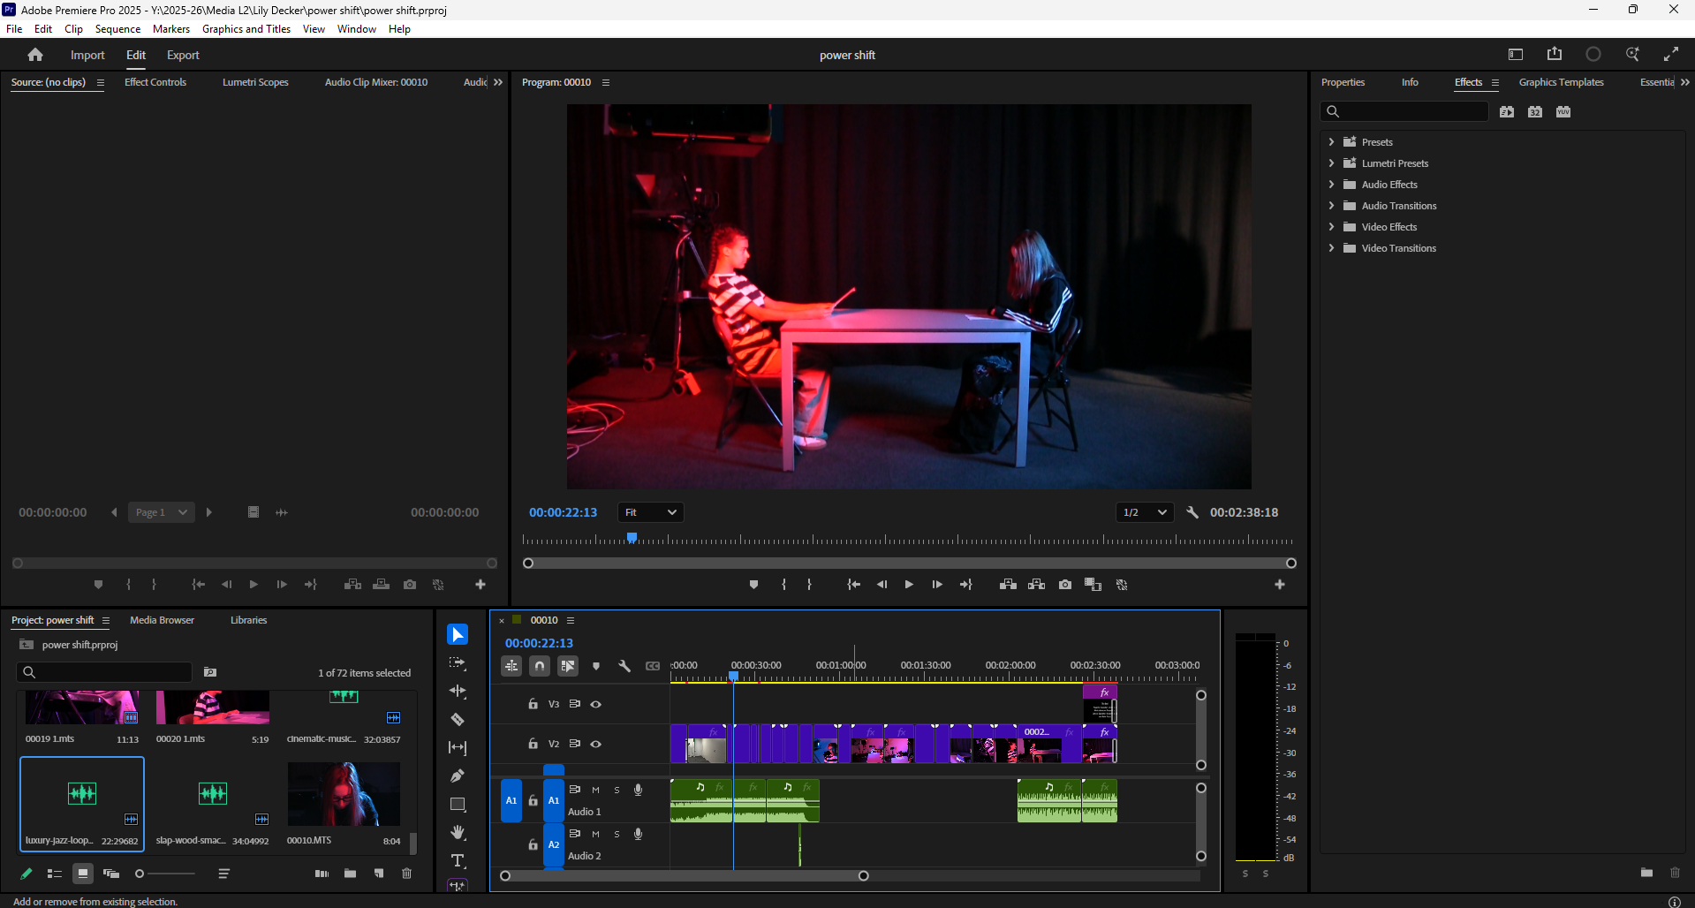

3rd – 5th of November: this week I started and completed an end of project worksheet where I had to write down where the documents would be found that would apply to the sentences. This was really difficult and stressful as I couldn’t understand what the sentences meant so I had to keep asking the lecturer for help and I was also stressed that I was getting the locations of the documents wrong but once I found out that I didn’t need to get it right and it just had to be found somewhere I was less stressed and I was able to complete the form in that day which I was very proud of myself for since it was so difficult. This week I also started going through my website checklist and ticking off everything I had done, and this wasn’t too difficult, but it was stressful because I had a list of all of the glossary terms I needed and I had a page and a bit left of terms I needed to add and I wasn’t confident that I’d be able to finish all of it soon.
10th – 13th of November: This week we started adding sounds to movie clips that had the sound removed and i chose batman and i found this really fun as i was able to put my own sounds into it that i found in pixabay but i did find it a little bit limiting as i originally thought i was only able to add 3 layers of sound in when i wanted more sounds at the same time such as music, rain, ambient car noise and tyres screeching. This week we had a sound effects workshop and i found this very fun trying to make different kinds of sounds especially with the rice, chain and cocktail shaker and with these things i made a really good ice shaker noise that i was really proud of. Another thing i liked about this workshop is how interactive it was. Something i did not enjoy about this workshop was the yogurt station where we had to put on gloves and make noises with yogurt and i did not like this because it was messy and i did not like the noises. Something i would do differently is i would try making noises with the cocktail shaker and the trays. This week i finished my batman movie clip edit and i was really happy with the final product as i figured it sounded quite realistic and i think all of the sounds i added made sense and lined up with what was going on screen very well and i also found out that i could add more layers of sound so that i could add more noises and this made me very happy as i was able to do what i wanted with the sounds and i was no longer limited.
17th – 20th of November: today i started my radio play assignment and we started by doing different accents such as american and australian and i found this really fun as it was quite silly and i do quite like doing funny voices sometimes so it felt less like a lesson and more like im having fun with my friends. after this we started figuring out what peice of media to adapt into a radio play and at first i was thinking of doing a scene from across/ into the spiderverse but i couldn't find a scene that was interesting enough and at the same time wasn't too complicated with the amount of characters and the voices/sound effects and eventually i gave up on trying to find a scene in that and then i moved on to a comic that i have about jeff the land shark and i figured this would be a good fit as it's interesting but not too complicated and it seems like it would be at least 10 minutes long which is the requirement so i found the comic online, screenshotted all of the pages and put them all into a powerpoint and started annotating for sounds that could be happening other than what's shown on the page such as birds chirping, snakes hissing, sparkling noises ect and this was fairly enjoyable as i was able to think of what could be going on in the background but is not shown on the page. This week we had to work from home for one day and i didn't manage to do much work before i had to go to maths at 1 but i had added a couple things to my comic annotations such as thunder noises when jeff is shown as angry when he hears the snakes. something i would do better is that i would start working earlier rather than using the day off to lay in for a bit. today i finished my sound effects annotations and then i started working on my sound effects list and this took quite a while and took up most of the lesson and i ended up with 61 sound effects once i had finished it and i was quite proud of being able to have that many but i also found it a bit scary because i dont know how I'll be able to record all of them and have time to edit the radioplay together before the due date and i then started working on my music ideas list and i had written 4 down which i wasn't too sure about as i wasn't sure if i had written enough for each song.
Friday 21st of November: today i had to finish my assignment before monday so even though i did not have college i started working on finishing my project and today i completed my script, my musical ideas and my voice ideas and something i found difficult was figuring out what to write for voice ideas as i knew what i wanted the characters to sound like but i didnt know how to explain it in words, for example for the snakes i wasnt too sure how to describe their voices but i could imagine how they could sound. Something that i found quite easy was writing the script as it seemed quite simple to look at my annotations powerpoint with the sounds i added and look at the comic in the powerpoint. Something that made this process far easier was having the comic physically in front of me as i own it as on the powerpoint it was a bit hard to read what the dialouge was as it was small and pixilated so using the physical comic was good to see the details that the powerpoint did not show.
24th – 27th of November: this week i started working on my production and this included finding sound effects online or on pixabay that i cannot or don't know how to make and putting it into a word document with a link on where to find it and this was fun but some of the music i struggled on finding such as the intro music and the music when the snakes get angry but eventually i found songs that i was really happy with and that i felt fit what was going on on that page. I then started putting my pages into premiere pro. Today i then started working on putting all my music into premiere pro and i felt that this really made the direction of how the radio play would go and i felt that it would end up being quite good as it the music made the pages come to life a bit more. I then started recording some of my sound effects and this didn't go too well as i only managed to record about 8 out of 68 and some of them were easy such as traffic noises and for that i just went outside and recorded the sounds of the cars going past but some of them were a bit harder such as wind noises from blowing into a microphone as i couldn't figure out how to make the wind noises loud enough so you could hear them but not too loud. This week i then started recording my dialogue for jeff which is my character, and this was quite fun and easy but i struggled a little bit with figuring out how to use adobe audition even though i wasn’t the one who was actually using it and it was other students but i wasn’t too sure about how to save the recordings i had made and had to get a teacher to do it, overall i was happy with what i had done and i had finished before the day ended at 12:15. This week we were told that level 2 group A’s and B’s would be combining their sound effects to save time as the deadline was next week but would be extended to the end of term and i didn't really like this idea as i personally do not trust a group of strangers to record sounds for me in the way that i want and i worry that the quality of these sounds will not be very good and i found that our class wasn’t getting told what we should be doing by the teachers and instead they were helping the other class and we weren’t being given any audio recorders to record sounds because they were being used by the other class and everything was a bit all over the place and it felt like nothing was planned so eventually i started putting the sounds i had made yesterday in premiere pro and then i ended up getting them out of order because they pretty much all sound the same because my character doesn't speak in words but rather in noises and so next Monday I'll have to remove all the sounds i added into premiere pro and add them back so i know which order they go in and this felt very pointless and i realise that i should have written down on my script what the name of the audio file is next to the dialogue so that i can put them in order correctly.

1st - 4th of December: today i removed the clips i had put into premiere pro of my jeff dialogue as i had mixed them up and hadn't noted down which clip attaches to which line and this is a problem because jeff makes a lot of the same sounds and i wanted to make sure the dialouge attached to the same clip i had made it for and to do this i went through my dialouge folder and found the first clip i had filmed, noted down the name of the clip i wanted to use on my script and put it into premiere pro. This complication gave me less time to complete my project when i could have been further ahead to completing it which would cause less stress on not completing it on time. if there is a next time of a situation like this i will note down what the name of the file is rather than just putting it all in. today i continued and finished noting down my clip names and although i didn't have a lot of time left i felt confident that I'd be able to finish everything by next week which is the deadline. i then started putting all of my clips in order and into the timeline and this was easy and I'd gotten half of my pages done with jeff's dialogue. after college i then worked on recording deadpool's dialogue with my boyfriend as deadpool and to do this i just used my phone and we only managed to get through 2/9 pages that have deadpool in them as he was struggling with some of the dialogue. today i continued and finished ordering my jeff clips into my timeline and this took a while but it was rather easy to do as i had all of the names of the clips in front of me. i then started recording my dialogue for aleister which is one of the snakes and recording for the narrator. this was really fun as i enjoyed speaking the lines how i've imagined them in my head during the creation of this project such as a loud, confident voice for the narrator
8th – 11th of December: today i did a reflection powerpoint and this was difficult but i managed to get it done through asking my group what they remember about our project and by looking back at my previous work and looking back at my previous work really helped because it reminded me of what was happening and how my power shift film turned out. today we did some filming for performing arts this was rather easy as my only job was to lay on the floor and hold the boom mic out of frame and this position ended up being rather uncomfortable and a little bit painful as i had to stay in the same position for about an hour and a half but i was told by one of the teachers that i held it very still and that i did a good job so that made me happy. today i continued my editing and I'd gotten around to wanting to put the recordings of one of the snake's dialogue into premiere pro but i realised that i hadn't given the recorder to my teacher and so they weren't uploaded and they'd been lost. next time i want to record something i will make sure once i am done it gets back to the teacher so that they can upload it. today i continued my editing but i wasn't exactly focused on doing my work so i didn't get a lot done other than adding in some dialogue for deadpool. next time i will make sure that i fully focus on my work so that i can complete it faster.

15th – 18th of December: today i continued working on my edit for my radioplay and i recorded the narrator’s dialogue, Anton's dialogue and Aleister's dialogue again as i had lost his the first time. I felt achieved as i had finally finished recording all my dialogue but a bit nervous as i only had 3 days left to finish everything and put it all together. Something that didn't go as well was that when i was recording my dialogue i could hear the headphones behind me echoing what i was saying and i found that quite distracting but i wasn't sure how to make it stop. Something i would do differently is figure out a way to make the headphones stop echoing what i was saying. Another thing we did today was that i started my justification document and the questions were rather easy such as why i chose the comic. Unit 5. 1.1, 2.1 I chose to create my audioplay in the way that i did by catering to marvel rivals fans by choosing to make the same or similar sounds that jeff makes in the game so that it is recognisable to them and they’ll enjoy it. Today was the due date for my assignment and i was very stressed as i had to add in a lot of my dialouge for 2 characters and i had a little bit left to add for deadpool. Something that didnt go well was that once the lesson had finished i still had half a character’s dialouge left to do so there were gaps left between the other characters lines and i just felt like i hadnt finished enough to pass the unit and i cant continue my edit at home because i dont have premiere pro at home but once i got home from college i finished my reflection and justification document and added them both into my website. Something that went well and that i enjoyed today was that i liked adding in the scary ominous noises of the shadow demon and the way that i did this was that i recorded audio of me blowing into the microphone and making scary noises and i layered them in premiere pro and made one of the layers lower pitched and i think this made it a lot scarier. Another technique i used was that i slowed down the scary noise to 20% and this made quite an ominious creepy noise which i liked. Overall i found this project alright but i think that i was more excited to do it at the start of the project because i didnt quite see how much stress would come from it from it being such a large project and having so many things to do such as recording dialouge and foley and editing it all together but at the end i just wanted it to be done and move on as i didnt enjoy the project anymore.

