Name: Lily Decker Date: 2/03/2026
Equipment list
Picture of equipment:
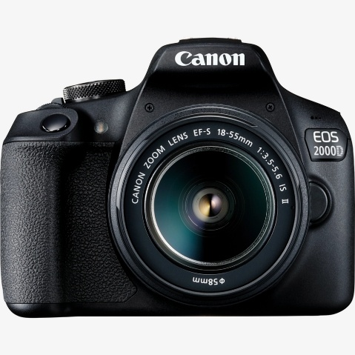
- Piece of equipment:
Canon DSLR EOS camera
I am using this camera because I used it last year for my photography project and I found it easy to use
Description:
Dates needed:
Person responsible:
3rd – 5th of March
Lily Decker (me)

Picture of equipment:

- Piece of equipment:
SD card
I will need this to upload my photos to the computer when I am done taking them
Description:
Dates needed:
Person responsible:
3rd – 5th of March
Lily Decker (me)

Picture of equipment:
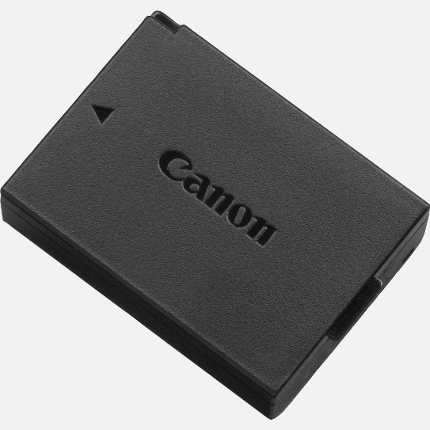
- Piece of equipment:
Canon battery
I will need this to allow me to use the camera and I will need to make sure it has a full battery before I go out and take my photos
Description:
Dates needed:
Person responsible:
3rd – 5th of March
Lily Decker (me)

Picture of equipment:
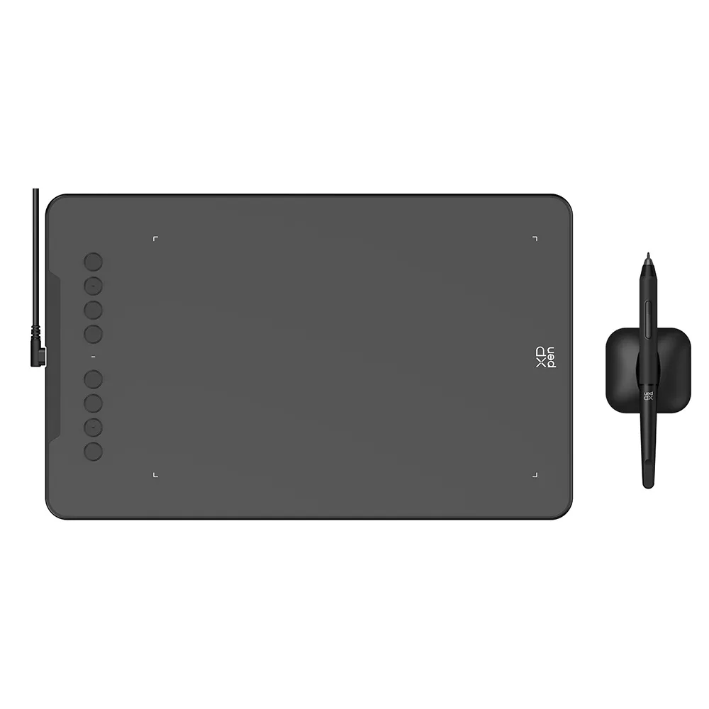
- Piece of equipment:
Drawing tablet
I am using this drawing tablet during my editing stage so that I can accurately and precisely remove the sky from the photo that I took
Description:
Dates needed:
Person responsible:
9th – 19th of March
Lily Decker (me)

Picture of equipment:
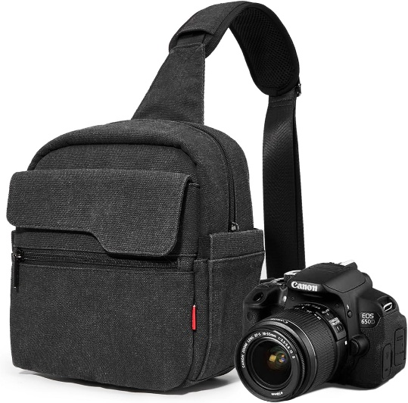
- Piece of equipment:
Camera bag
I will need a camera bag because I am walking a bit far between locations as one of my locations is next to the leisure park which is about a 15 minute walk from town and I want to ensure that the camera is safe and I don’t drop it or it gets stolen.
Description:
Dates needed:
Person responsible:
3rd – 5th of March
Lily Decker (me)

