Name: Lily Decker 26/02/2026
FMP Location recce
Location 1: Next to the police station
Photo of location
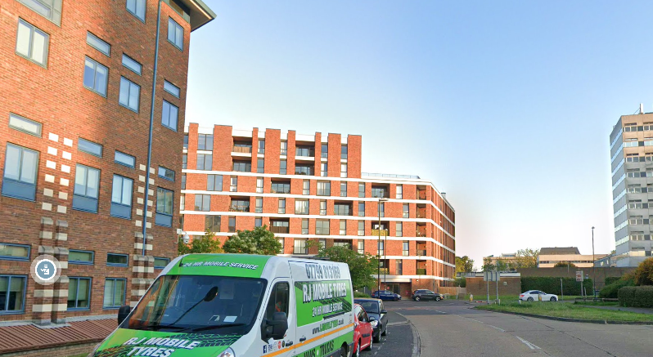
Site contact | Me | Site address | Northgate Ave, Crawley RH10 8BF
Contact number | My phone number: 07471788753 | Electricity supply | At college
Permissions | N/A | Lighting | Natural sunlight
Availability | Always available
Points of interest | Bridgefield house flats top right corner
Possible shots | A photo of the top right of the flats with the sky behind it
Safety issues | The place I will be standing is a crossing island in the road so I will need to be safe with the cars and crossing the road

Location 2: Southgate avenue by Town Centre South bus stop
Photo of location
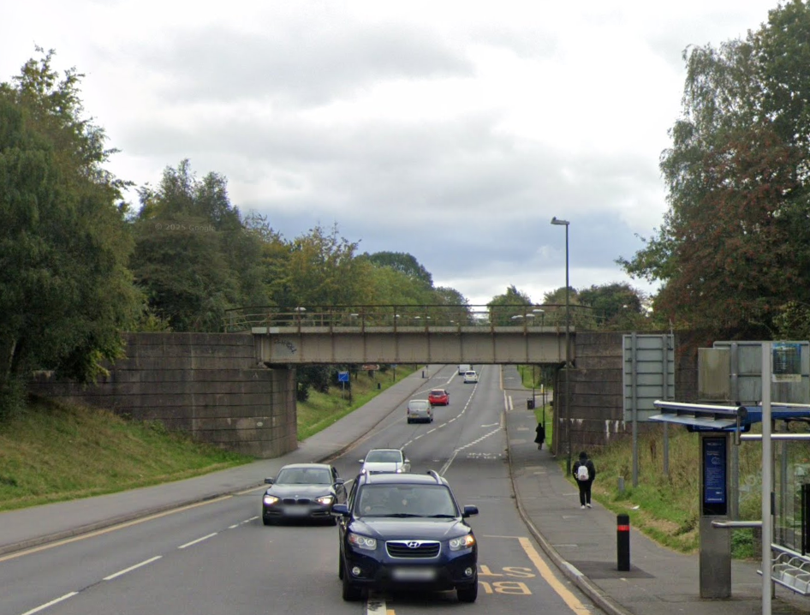

Site contact | Me | Site address | Town centre south bus stop
Contact number | My phone number: 07471788753 | Electricity supply | At college
Permissions | N/A | Lighting | Natural sunlight
Availability | Always available
Points of interest | The train bridge over the road
Possible shots | Taking a photo of the bridge and the sky above it
Safety issues | The place I will be standing is a crossing island in the road so I will need to be safe with the cars and crossing the road

Location 3: The glass on the county mall on the side of the library
Photo of location
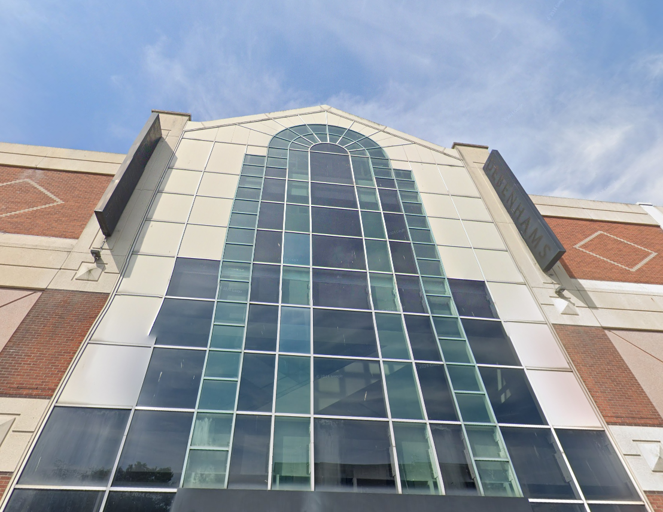
Site contact | Me | Site address | Crawley library, Southgate Ave, Crawley RH10 6HG
Contact number | My phone number:  07471788753 | Electricity supply | At college
Permissions | N/A | Lighting | Natural sunlight
Availability | Always available
Points of interest | The glass on the side of the mall by the library
Possible shots | A photo of the glass with the sky above it and I stand by the library
Safety issues | No safety issues

Location 4: The council building
Photo of location
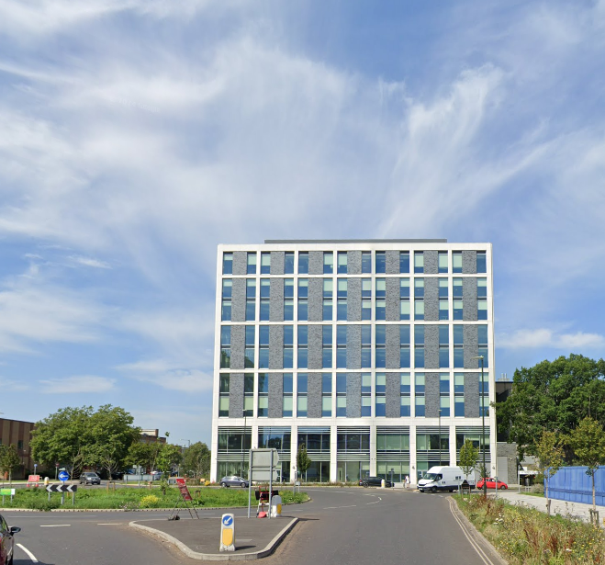
Site contact | Me | Site address | The Boulevard, Crawley RH10 1UZ
Contact number | My phone number:  07471788753 | Electricity supply | At college
Permissions | N/A | Lighting | Natural sunlight
Availability | Always available
Points of interest | The council building
Possible shots | A photo of the council building from across the road at the traffic lights
Safety issues | No safety issues

Location 5: Griffin house near Wingstop and leisure park
Photo of location
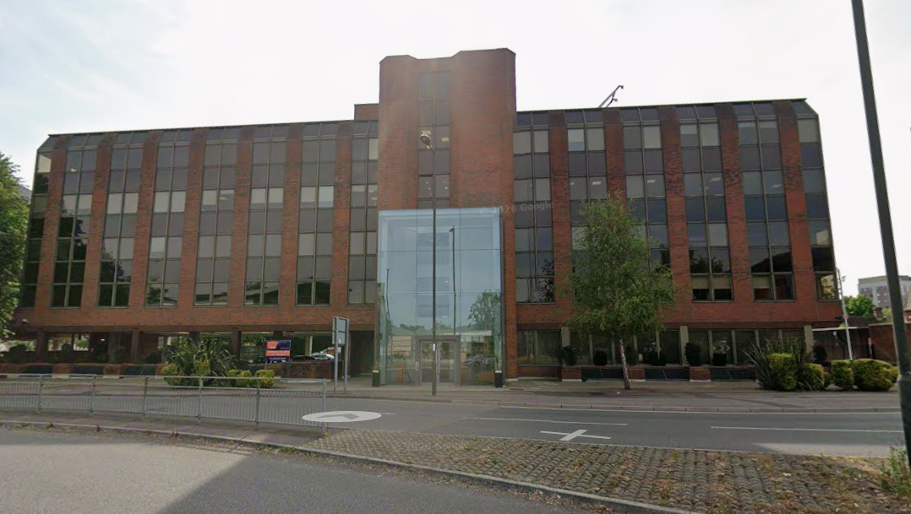
Site contact | Me | Site address | Griffin House, 135 High St, Crawley RH10 1DQ
Contact number | My phone number:  07471788753 | Electricity supply | At college
Permissions | N/A | Lighting | Natural sunlight
Availability | Always available
Points of interest | Griffin house
Possible shots | A photo from across the road of the building and having the middle part centred with the sky above it
Safety issues | No safety issues

